Kendriya Vidyalaya Vasant Kunj(SHIFT-1)
Holidays homework summer vacation (2020-21)
Class- 9th A

ग्रीष्मकालीन गृहकार्य
कक्षा 9, हिंदी

1.अलंकार किसे कहते हैं? इसके कितने भेद होते हैं? उदाहरण सहित लिखो।
2.अनुप्रास अलंकार,यमक अलंकार,श्लेष अलंकारों की परिभाषा उदाहरण सहित लिखो
3.क्षितिज भाग 1 के प्रथम तीन अध्यायों:-1दो बैलों की कथा 2 ल्हासा की ओर 3साँवले सपनों की याद का सार अपने शब्दों में लिखो।

4. अर्थ के आधार पर वाक्य भेद लिखो।
5.निम्नलिखित विषयों पर अनुच्छेद लिखो
मैं सुरक्षित तो देश सुरक्षित, देश हित सर्वोपरि, एकता में बल, सपनो का शहर दिल्ली, मैं घर मे हूँ तो सब सुरक्षित।
6. किन्ही पाँच उपसर्गों के अर्थ और उदाहरण लिखो
उपसर्ग--अर्थ-----उदाहरण
7 कोई एक अनौपचारिक पत्र लिखो
8 कोई एक औपचारिक पत्र लिखो
सारा कार्य हिंदी की कॉपी में करना है।

(Subject : S.St.)

- Read the following chapters properly, make gist (main important points) and learn :
History – Ch-1,2 Geography – Ch 1,2 Economics- Ch 1, Democratic Politics(Civics)- Ch-1,2

- Learn exercise questions and inside questions of above mentioned chapters and practice by writing on pages (Plane / Lined paper) and put in activity file.

- Write 10-10 one marked questions of above mentioned chapters on pages (Plane / Lined paper) and put in activity file & Learn.

4. Practice Map of Geography Ch 1,2,3 and put in Activity File. (Photo copy of map is not allowed.)

5. Do project and put in activity file :-
Disaster Management Book : Ch-1 Introduction to Disaster Management &
Ch-2 Common Hazards, Prevention and Mitigation
6. Write about the help provided by you or your family to the society or needy people during COVID 19 lockdown and put in activity file.
7. Make a list of all states and union territories with capital. Label on political map of India.
(Do on pages and put in activity file)
** Note : Make an Activity File. Make its 1st page as :
(Activity File of Social Science (2020-21)
Class & Sec : Name :

9th A Science holiday homework:
1. Classify the following into osmosis/diffusion
(a) Swelling up of a raisin on keeping in water.
(b) Spreading of virus on sneezing.
(c) Earthworm dying on coming in contact with common salt.
(d) Shrinking of grapes kept in thick sugar syrup.
(e) Preserving pickles in salt.
(f) Spreading of smell of cake being baked throughout the house.
(g) Aquatic animals using oxygen dissolved in water during respiration.
2. Make a list of vaccine which is mandatory for all children in India.
3. Write 10 ways to improve your immunity.
4. a. Make a list of instrument in which speaker is used.
b. Explain the working of speaker.
5. Make a list of female scientists and discuss their contribution.
6. Watch a science fiction movie or TV series and write its story in your own words. Explain the scientific principle shown in the movie.
7. Learn and write laws of motions and write 10 examples of each law which you see or use in your daily life.

Class- 9
Subject- Maths

QUESTION 1. Which one is not a polynomial
(a) 4x² + 2x – 1
(b)
(c) x³ – 1
(d) y² + 5y + 1
QUESTION 2. The polynomial px² + qx + 5 is
(a) linear
(b) quadratic
(c) cubic
QUESTION 3. The zero of the polynomial p(x) = 2x + 5 is
(a) 2
(b) 5
(c)
(d)
QUESTION 4. The number of zeros of x² + 4x + 2
(a) 1
(b) 2
(c) 3
(d) none of these
QUESTION 5. The polynomial of type ax² + bx + c, a = 0 is of type
(a) linear
(b) quadratic
(c) cubic
QUESTION 6. The value of k, if (x – 1) is a factor of 4x³ + 3x² – 4x + k, is
(a) 1
(b) 2
(c) –3
(d) 3
QUESTION 7. If 3 + 5 – 8 = 0, then the value of (3)³ + (5)³ – (8)³ is
(a) 260
(b) –360
(c) –160
(d) 160
QUESTION 8. The value of 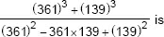
(a) 300
(b) 500
(c) 400
(d) 600
QUESTION 9. If x + 2 is a factor of x³ – 2ax² + 16, then value of a is
(a) 3
(b) 1
(c) 4
(d) 2
QUESTION 10. If one of the factor of x² + x – 20 is (x + 5). Find the other
(a) x – 4
(b) x + 2
(c) x + 4
(d) x – 5
QUESTION 11. State whether the following statements are true or false
(i) 2√525 is a rational number.
(ii) There are infinitely many integers between any two integers.
(iii) Number of rational numbers between 11 and 13 is finite.
(iv) There are numbers which cannot be written in the form p/q , q ≠ 0 , p, q both are integers.
(v) The square of an irrational number is always rational.
(vi)√18√2182 is not a rational number as √1818 and √22 are not integers.

QUESTION 12.
Cross-word Puzzle
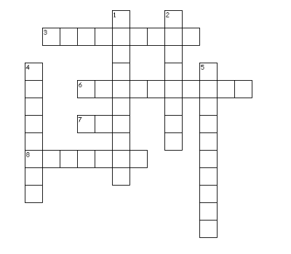
Across
3. rational numbers have only two choices- either they are terminating or non-terminating ________
6. The First person to discover the numbers which were not rational
7. The number (√3 -1)(√3 +1) is
8. Counting Number are called
Down
1. Non-terminating non recurring decimal expression
2. The set of positive and negative number is
4. Number of the form p/q
5. Who was the first to compute digits in the decimal expansion of π(Greek genius )
QUESTION 13. Write the following in decimal form and say what kind of decimal expansion each has:
(i) 1910019100
(ii) 1313
(iii) 11121112
(iv) 113113
(v) 313313
(vi) 111400111400

PISA BASED QUESTIONs
QUESTION 14. Coins
You are asked to design a new set of coins. All coins will be circular and coloured silver, but of different diameters. Researchers have found out that an ideal coin system meets the following requirements:
• diameters of coins should not be smaller than 15 mm and not be larger than 45 mm.
• given a coin, the diameter of the next coin must be at least 30% larger.
• the minting machinery can only produce coins with diameters of a whole number of millimetres (e.g. 17 mm is allowed, 17.3 mm is not).

Question 1: You are asked to design a set of coins that satisfy the above requirements. You should start with a 15 mm coin and your set should contain as many coins as possible. What would be the diameters of the coins in your set?
QUESTION 15. DRUG CONCENTRATIONS
A woman in hospital receives an injection of penicillin. Her body gradually breaks the penicillin down so that one hour after the injection only 60% of the penicillin will remain active. This pattern continues: at the end of each hour only 60% of the penicillin that was present at the end of the previous hour remains active.
Suppose the woman is given a dose of 300 milligrams of penicillin at 8 o’clock in the morning. Complete this table showing the amount of penicillin that will remain active in the woman’s blood at intervals of one hour from 0800 until 1100 hours.
Time | 0800 | 0900 | 1000 | 1100
Pencillin(mg) | 300

QUESTION 16. ONLINE GAME
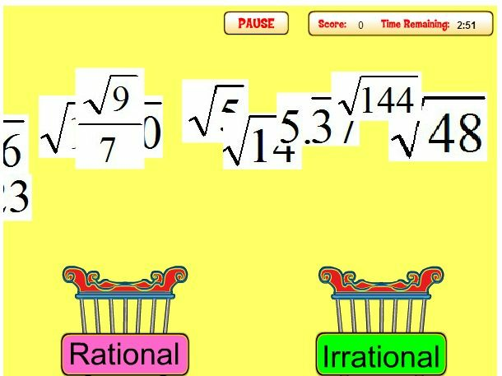
Reeta and Geeta are twin sisters. They both study in class IX.They love to study Maths as it is their favourite subject.These days they are not going to school and having online classes only due to Corona pandemic. They are somewhat bored as they miss their school friends. One day they decide to play online quiz. The quiz is about rational and irrational numbers. One by one they are given a number on screen. They have to identify that number as rational or irrational and put that number in the correct bin as shown in picture. They get +10 points for correct answer and -5 points for incorrect answer.
Following is the detail of their responses after finishing the game.
Reeta’s responses |  | Geeta’s responses
Rational | Irrational | Rational | Irrational
5/7 | √3 | 5 | 0.777777…
√25 | 4π | 28/99 | 25.252525…
5.1211114444… | 1.5125473694… | -5 | √49
8.5 | 1.5 | 0 | 22/7
0.333333… | √47 | 5789.2 | 0/5

Q.1 Who won the game?
(a) Reeta
(b) Geeta
(c) Both got equal score
Q.2 Geeta says that 22/7 is an irrational number as it is value of π(pi) but Reeta disagrees with her and says that 22/7 is a rational number. What do you think, who is correct? Explain your answer.
Q.3 Identify, whether 25.252525… is a rational or irrational number. Justify your answer.

SUBJECT : ENGLISH

- Write articles on
- Social Distancing in Covid period.
- Swach bharat Abhiyan or Clean India campaign.
- Online Education and its importance.
- Cruelty to animals.
- Respect towards elders.

- Revise the lessons 1 to 2 and the poem ‘Road not taken’ from your text book ‘Beehive’ and write summary in your notebook.

- Practise editing and omission from workbook.

- Write meanings of five difficult words daily from your textbook/or any other source.

- You are Amar/Sheela, a student of KV, Vasant Kunj, New Delhi-110070. You are concerned about water logging in front of your school during rainy season. Write a letter to the editor of an esteemed newspaper highlighting the urgency to remove the water logging and need to improve the condition of road in front of your school.

- Write a story in 200-250 words with the help of the clues given below. Also give a suitable title to the story and write moral of the story:
Going to Mumbai by train to attend the marriage of friend’s brother – got stuck in a traffic jam – reached the railway station late – boarded a wrong train – realized after two hours – now you……..

***

