Kendriya Vidyalaya Vasant Kunj (shift-1)

Holiday Homework for SUMMER VACATION(2020-21)

CLASS- 8-A & 8-B

SUBJECT: SCIENCE

1. Paste pictures of 5 modern agricultural tools and write about them.
2. Make a project on topic “pollution caused by burning of fossil fuel”
3. Paste the photographs of synthetic fibres you used in your daily life.
4. Write the advantages and disadvantages of
a. synthetic fibres
b. plastics
c. fertilizers
d. coal and petroleum
e. Radioactive elements
5. Write the rules of PCRA to conserve petroleum
6. Make a list of astronomical events which happened from 1st January 2020 to 25th July 2020.
7. Make a working model with the help of elder (any 1)
a. Water alert system in tank
b. An electric circuit consist of wire, switch and LED or Buzzer
c. Solar Eclipse/Lunar eclipse
SUBJECT: हिन्दी
ग्रीष्मकालीन अवकाश गृह कार्य-
1.वसन्त पाठ्य-पुस्तक के पहले तीन पाठों के प्रश्नों के उत्तर लिखना तथा याद करना।
2.भारत की खोज पुस्तक के पहले दो पाठों के प्रश्नों के उत्तर लिखना तथा याद करना।
3.औपचारिक तथा अनौपचारिक पत्र लिखना।( पांच-पांच )
4.अनुच्छेद लिखो-
* महामारी-एक समस्या, मेरा प्यारा देश भारत, तकनीक का शिक्षा में प्रयोग, अनुशासन का महत्व, जीवन में योग ।
5.लेखन व वर्तनी में सुधार का अभ्यास करें ।

SUBJECT: MATHS

Q1. Write the definitions of:
- Natural Numbers
- Whole numbers
- Integers
- Rational numbers
In support of your answer, also represent a few of each type on a number line.
Q2. Mention the commutativity, associative and distributive properties of rational numbers. Also, check a × b = b × a and a + b = b + a for a = ½ and b = ¾
Q3. Write any 5 rational numbers between −2/5 and ½.
Q4. Represent −𝟐/𝟏𝟏, −𝟓/𝟏𝟏, and −𝟗/ 𝟏𝟏 on the number line.
Q5. A positive number is 5 time another number. If 21 is added to both the numbers, then one of the new numbers become twice of other new numbers. Find the original numbers.
Q6. The sum of three consecutive multiples of 8 is 888. Find the multiple.
Q7. Five years ago, Anu was thrice as old as Sonu. After ten years, Anu will be twice as old as Sonu. How old are Anu and Sonu?
Q8. Three consecutive integers are as such they are taken in increasing order and multiplied by 2, 3, and 4 respectively, they add up to 56. Find these numbers.
Q9. There is a narrow rectangular plot. The length and breadth of the plot are in the ratio of 11:4. At the rate of Rs. 100 per meter it will cost village panchayat Rs. 75000 to fence the plot. What are the dimensions of the plot?
Q10. Convert the following statements into equations.
(a) 3 added to a number is 11
(b) 2 subtracted from a number is equal to 15.
(c) 3 times a number decreased by 2 is 4.
(d) 2 times the sum of the number x and 7 is 13.
Q11. The sum of three consecutive odd numbers is 51. Find the numbers.
Q12. A sum of Rs.2700 is to be given in the form of 63 prizes. If the prize is of either Rs.100 or Rs.25, find the number of prizes of each type.
Q13. The angles of a quadrilateral are in the ratio of 1:2:3:4. What is the measure of the four angles?
Q14. In quadrilaterals,
(i) which of them have their diagonals bisecting each other?
(ii) which of them have their diagonal perpendicular to each other?
(iii) which of them have equal diagonals?
Q15. Find the angle measure x in the following figures.
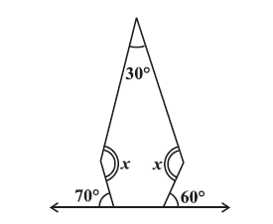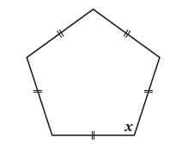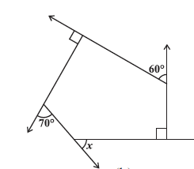
Q16. Explain why a rectangle is a convex quadrilateral.
Q17. Explain how a square is.
- a quadrilateral (ii) a parallelogram (iii) a rhombus (iv) a rectangle
Q18. State whether True or False.
(a) All rectangles are squares (e) All kites are rhombuses.
(b) All rhombuses are parallelograms (f) All rhombuses are kites.
(c) All squares are rhombuses and also rectangles (g) All parallelograms are trapeziums.
(d) All squares are not parallelograms. (h) All squares are trapeziums.
Q19. Draw a rough figure of a quadrilateral that is not a parallelogram but has exactly two opposite angles of equal measure.
Q20. The following figures GUNS and RUNS are parallelograms.
Find x and y. (Lengths are in cm)

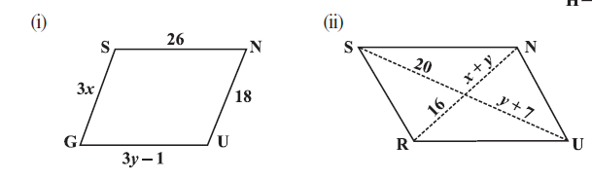
Q21. Prepare a powerpoint presentation on the properties of qudrilaterals .
PISA BASED QUESTIONS
- To emphasize the importance of fitness, K V 1 hindan has made one mandatory period of sports daily. Currently school is having facilities only for football and basketball, there are 4 y² + y -8 students of class VIII, if 2 y + 16 students play football, how many opt basketball? It is compulsory for each student to play one game.
- An auto manufacturing company wants to compile a profit /loss statement. Total sale for the year 2019 is given by expression 1.75 x² + 1.25 x + 7 ,where x is number auto manufactured per year .The total cost of producing x autos is given by expression 1.03 x² + 1.21 x - 4 . What is the total profit earned by the company for the year 2019?
- Veena’s mother gave her Rs. 2 xy²and her father gave her Rs. 7 (xy²+ 3). She spent Rs (3 + 4 xy²) on her shopping. Algebraically how much money is left with her?

SUBJECT: ENGLISH

- Write 20 pages of handwriting in Cursive book or in a simple notebook.

- Read, learn and revise the Lesson No. 1 to 2 from your text book ‘Honey Comb’ and Poem Lesson No. 1 from your text book ‘It so Happened’.

- Practise active and passive voice.

- Write Paragraph on

a). Importance of Good Health.
b). Value of Descipline.
c). A helpful person I have met.
d). A funny time in my family.

- Letter Writing
Write a letter to your friend congratulating him/her on his success in Green Olympiad.
- Application
Write one application for T.C. As your father has been transferred to Kolkata from Delhi.

- Write a letter to your grandfather mentioning the reasons for not being able to come to see him during this summer vacation.

- Practise Editing and Omission.

- You are Anupam/Anuradha, the editor of the school magazine and want to hold an inter class competition to collect poems and cartoons for the school magazine. 2020. Draft a notice for the Students Notice Board inviting entries before 20th of June, 2020. Mention all the details required like entry dates, prizes and opportunity available for article to be published in school magazine. Give an appealing heading to your notice.

Subject : S.St.
- Read the following chapters properly, make gist (main important points) and learn :
History – Ch-1,2,3,4 Geography – Ch 1,2,3 Civics- Ch-1,2,3

- Learn exercise questions and inside questions of above mentioned chapters and practice by writing on pages (Plane / Lined paper) and put in activity file.

- Write 10-10 one marked questions of above mentioned chapters on pages (Plane / Lined paper) and put in activity file & Learn.
4. Practice Map of Geography Ch 1,2,3 AND History – Ch-1,2,3,4 from Book(if given in book) and put in Activity File. (Photo copy of map is not allowed.)
5. Project : Write about the help provided by you or your family to the society or needy people during COVID 19 lockdown and put in activity file.
6. Make a list of all states and union territories with capital. Label on political map of India.
Make list of chief ministers of the states and Lt governors of all states and union territories.
[Do the work on page and put in Activity file.]
** Note : Make an Activity File. Make its 1st page as :
(Activity File of Social Science (2020-21)
Class & Sec : Name :

SUBJECT: SANSKRIT
